Moodle Sharing Cart 
The Moodle Sharing Cart is a plugin tool that allows instructors to quickly and easily duplicate resources, activities, or entire sections and move them between different Moodle courses. You can copy individual items, resources, activities and even an entire section (tile, week, topic).

For a visual walkthrough of the Moodle Sharing Cart process, view the Moodle Sharing Cart Video Demonstration otherwise, follow the steps below.

How to Utilize Sharing Cart:
- Go into the Moodle course where the content you need is currently listed.
- Turn editing on, and scroll down to the bottom of the right-hand menu and click Add a Block. (If you do not see the right-hand menu, click the open block drawer (<) at the top left of your course page to unhide the menu.)

- Select Sharing Cart from the Add a block list.
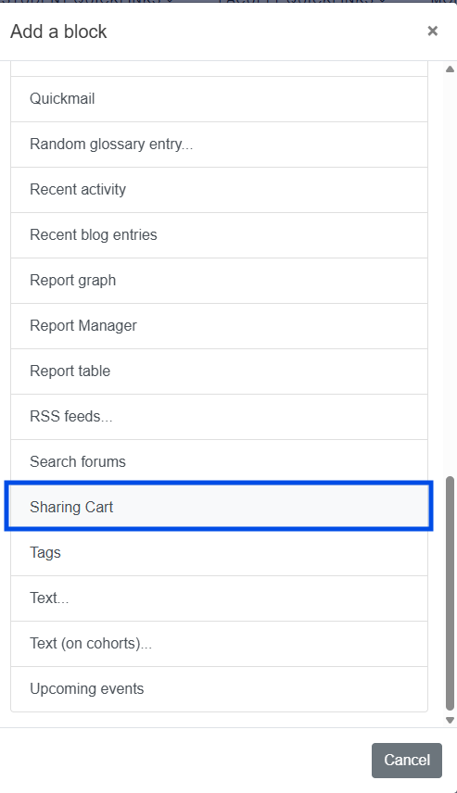
- The Sharing Cart block will appear on the right side of your main course page. (Usually as the very last block on the right, but occasionally higher up.) You will notice once the block is added that you see little basket icons to the right of every item and section on your course page.
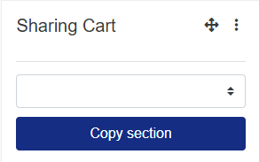
- Click the basket icon to the right of the item you want to copy into the cart. A copy of the item will appear in the cart. (If you are copying a page section, it will appear as a folder icon in the Cart.)
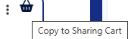
- Once you have added all the items you need into the Sharing Cart, go to the class into which you want to add these items.
- Repeat the process (steps 1-3) to add the Sharing Cart into the class.
- In the Sharing Cart block, click the duplicate icon (stacked boxes) to the right of the item you want to place in the course. You will see a dotted line box appear in each section on the course page.
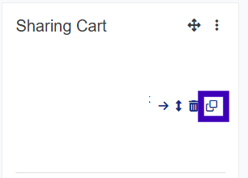
- Click the dotted line box in the section where you want the item to appear. The item will appear in the selected location. You can move it as usual within that page section once it appears.

NOTE: If you are copying an entire page section (title, week, topic), you will need to add it to a blank section of your course page as it will overwrite the title, week, or topic section it is being copied into. You may see a section conflict message that asks you to choose how you would like the content to be copied. Be careful not to overwrite a section that contains content. Review imported content and update any due dates or settings as needed.

